Name ____________________________

1-4 State the domain and the zeros of the following:
1) 2)

3) 4)

Sketch the graph of the reciprocal of each of the following on the given grid.
5)
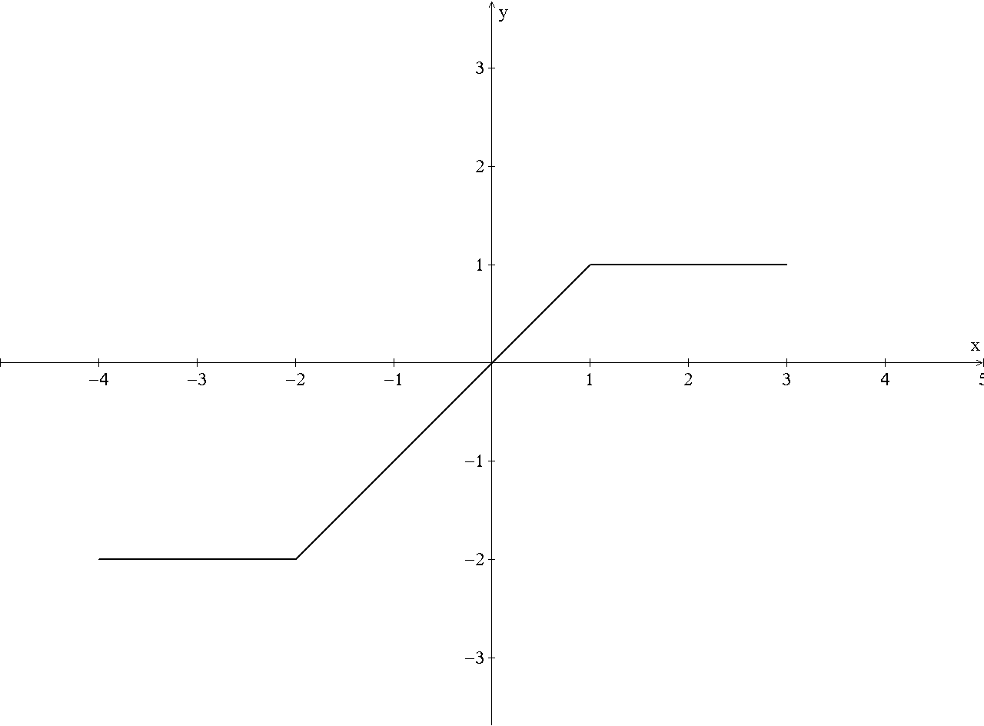
6)
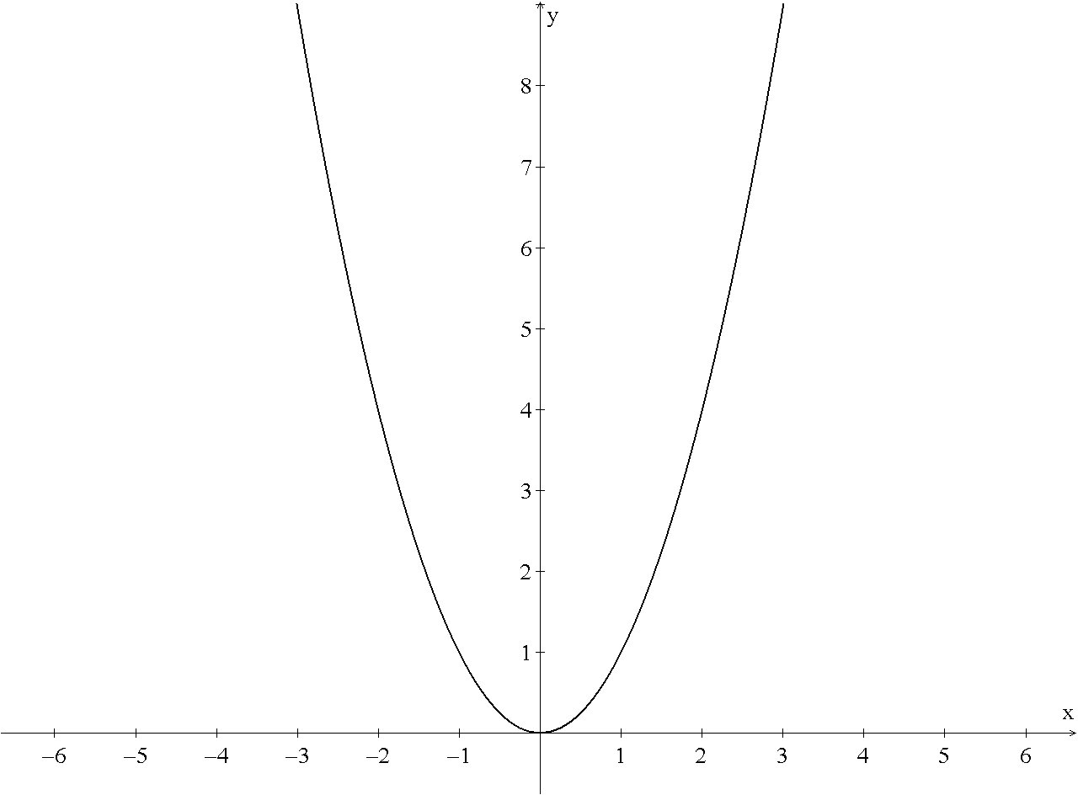

7)
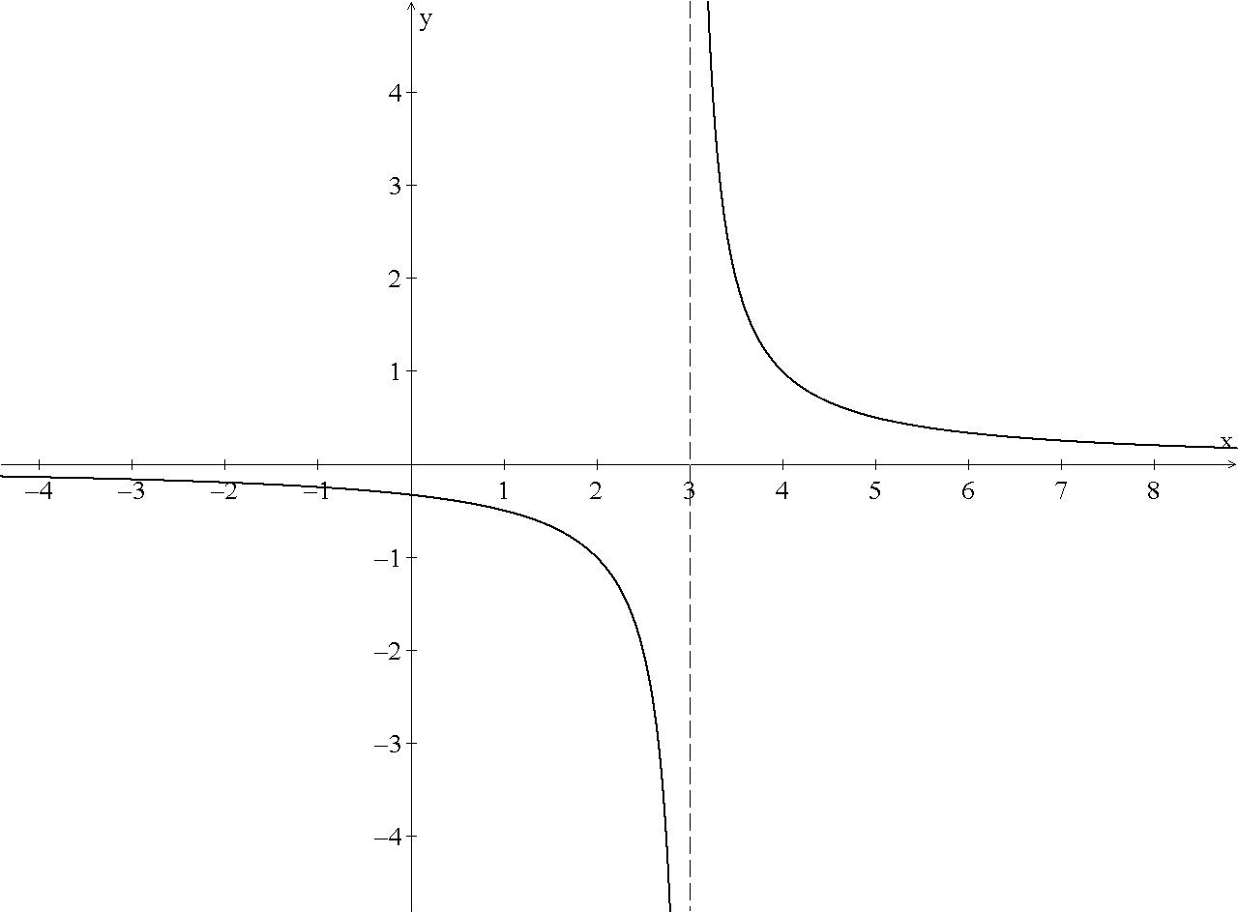
8) Make a conjecture about when a graph’s reciprocal will have a vertical asymptote.

